Summary: professional prediction fashions are required by way of people, schools, and organizations within the evolving process. The research shows a system gaining knowledge of versions for predicting someone’s career path based on skills, schooling, and experience. Skilled in giant datasets of career trajectories, the version uncovers styles that allow notably correct predictions. It assists individuals in making knowledgeable choices, allows instructional establishments to align their curriculum with market needs, and permits corporations to refine their hiring and training methods. Furthermore, it identifies ability gaps for focused development. By way of that, specializing in career development within Indian corporations, this research highlights the significance of strategic career planning, flexible academic packages, and improved workforce techniques to satisfy evolving skill necessities and technological advancements.
Keywords: profession prediction models, career course forecasting, career choice-making, and academic curriculum alignment.

1. Advent
Career prediction models use machine learning algorithms to evaluate a character's abilities, training, and paintings experience, identifying patterns from historical facts to correctly forecast career trajectories. Those fashions provide treasured insights, allowing people to make informed decisions, instructional institutions to tailor curricula to meet industry demands, and groups to decorate their hiring and schooling procedures. as the job marketplace evolves because of technological improvements, automation, and shifting needs, profession prediction models address the necessity for a records-pushed approach to career improvement. They identify ability gaps, sell expert growth, and assist organizations in navigating demanding situations which include monetary fluctuations, body of workers diversity, and regulatory modifications. This research provides a sturdy system for understanding models that offers a practical framework for improving career-making plans and ensuring achievement for people, institutions, and groups.

2. LITERATURE SURVEY

As corporations, individuals, and institutions try to maximize the number of workers, gadget learning algorithms have increasingly been implemented in career prediction models in recent years. One technique utilized is dendrograms, which give a hierarchical illustration of the interconnectivity among various professional paths. This phase gives an outline of the research conducted on career dendrogram prediction models.
J. Allan McCarthy and James L. Moseley, in "A Hierarchical Framework for Career Planning and Improvement," suggest a formal version of career development. They argue that the complexity of the process marketplace requires a hierarchical technique. They hire dendrograms to illustrate the connection between professional pathways in their model, permitting people to make knowledgeable career choices.

Moghaddam and Aliabadi’s "Professional Prediction in Technology: A Clustering-based Hierarchical technique" utilized dendrograms to analyze tendencies in engineering careers. They hired hierarchical clustering to compare various professional prospects in engineering and their correlations, presenting valuable facts on career paths.

Ok. Ann Renninger and Ruthellen Josselson proposed an opportunity version of profession exploration in their paper "profession timber: a unique version for inspecting Careers." In preference to using dendrograms, they added career trees as a distinct visualization device to represent career paths. Professional timber commonly emphasizes personal decision-making approaches, even while additionally considering the interconnectivity among various professional paths. This version permits people to apprehend the capacity implications of their professional choices.

Any other take a look at making use of Hierarchy in career guidance models is "Career Paths in Era: A Hierarchy-based Clustering method" by Moghaddam and Aliabadi. The authors used hierarchical clustering to research and identify traits in the professional paths of engineering specialists. Their dendrogram-primarily based version provided treasured insights into career paths and their interdependencies within the engineering discipline.

Susan B. Davidson and Timothy R. Tymon proposed a career lattice version for IT professionals of their paper titled "A Professional Lattice Model for IT Specialists." They utilized dendrograms to illustrate the relationships among paths in the IT field. This approach mentioned unique professional trajectories and diverse career paths for IT professionals and recognized the vital talents required for each course.

The exploration of dendrogram programs in career guidance structures has yielded valuable insights for people, educational establishments, and companies, enhancing the know-how of professional paths and their interdependencies. Researchers which including McCarthy, Moseley, Moghaddam, Tymon, and Davidson, have made significant contributions to the improvement of these fashions. Their research has tested the transformative capacity of dendrogram-primarily based techniques in shaping career development techniques.

Professional planning and management are important additions to professional improvement. Puah and Ananthram (2006) emphasized the necessity of aligning organizational profession management practices with man or woman profession planning to facilitate effective career development, an idea previously underscored through Hall (1986). Likewise, Nicoara (2009) highlighted the importance of balancing human aid desires with personal professional aspirations.

Within the subject of drugs, Denise L. Hummel and Ruth S. Freedman applied dendrograms of their research titled "A Professional Trellis for Healthcare experts." Their model elucidated the interrelationships amongst various professional opportunities within the clinical career, highlighting the various paths available to clinical professionals and the skills important to excel in each position.

Sizeable studies on the software of dendrograms in professional forecasting models have been conducted, resulting in the creation of new understanding on professional development and the body of workers. The effects of those models continue to power the dynamic profession planning and professional improvement discipline.

CHARACTERISTICS:

In our studies take a look at, we are featuring a professional dendrogram predictive model that uses the random forest approach. While examining past studies on profession prediction models, we came across the maximum common methods utilized in creating predictive models. From our study findings, the most useful technique a number of the others was the random forest set of rules. It’s miles a system learning approach wherein more than one selection tree is created and their prediction aggregated to improve reliability and accuracy. In our career dendrogram model, those selection bushes are diverse career paths, and their aggregated prediction yields meaningful relationships among various professional paths.

There are some steps in our method. First, process positions, required capabilities, stages, and enjoyment level statistics are amassed from job postings, instructional institutions, and enterprise reports. 2d, the accumulated information is preprocessed, wherein duplicates and irrelevant information are removed and great attributes are normalized. Function engineering is likewise used to create extra variables that yield meaningful relationships among various factors. After record coaching, we initialize the version based on the random forest algorithm, wherein a couple of choice trees are created on random functions and feature subsets. The aggregated predictions of a majority of these timber yield distinct career predictions.

For the performance assessment of the version, we use accuracy, precision, keep in mind, and F1-rating measures with pass-validation to ensure reliability. We additionally take a look at and graph the model consequences to make crucial observations. From the examination of the decision timber, we will discover the maximum essential elements for career prediction, and dendrograms are used to represent the correlations among one-of-a-kind career choices. This systematic approach of profession prediction makes beneficial observations, enabling people, schools, and companies to make knowledgeable selections towards profession making plans and professional development.

3. LOGIN PAGE
The career Dendrogram Forecast model is constructed the usage of HTML, CSS, and JavaScript, with a backend that makes use of the Random Forest set of rules. It facilitates users' customized insights into diverse career paths, helping people, educational institutions, and businesses in making knowledgeable professional choices with the aid of comparing a person’s abilities, schooling, and experience. The platform guarantees a smooth user experience via a properly crafted dashboard that includes a login page and different interactive functions. After registering and logging in, customers can access the prediction device by submitting their profile information. The version then affords personalized career tips, which are visually displayed as a dendrogram, illustrating career paths and their connections.

4. UI DESIGN

The user interface of our career Dendrogram Prediction
The model is a login page that contains the following components:

Username and Password Fields: The customers are required to input their credentials a good way to make use of the prediction tool. The credentials are created throughout registration.

Registration Button: New customers can make use of this button to sign up for an account. During registration, users are required to enter private info together with their name, email deal with, and speak to range.

5. INPUT FORM

Our profession Dendrogram Hierarchical Prediction version interface has an advanced records entry, wherein a person can input information about their abilities and educational historical past so that they get career tips appropriate for them. The form is designed to take the person's modern process designation, educational qualification, painting experience, skill set, preferred career purpose, desired industries, favoured location for painting, desired time table for painting, preferred profit variety, and preferred work surroundings.

6. SUBMIT AND RESULTS

Publish Button: one can press "post" after filling in their statistics so that they get career tips particular to them.

Results web page: tips are displayed as a hierarchical structure indicating paths and their relationship. Users might also click on nodes to view extra information about a person's career.

Random woodland set of rules:

The Dendrogram-primarily based Hierarchical Career Prediction model employs the Random Forest set of rules is applied to tailor-made career recommendations for customers by way of studying their talents and qualifications. Random woodland is an extensively used system getting to know techniques because of its effectiveness in performance on the subject of classification and regression issues. In our model, a Random wooded area is employed to forecast the high-quality career options for customers.

The Random Forest algorithm is based on an ensemble of choice trees wherein each tree is trained on a randomly selected subset of the training set. People independently make predictions, and the collective output is calculated by aggregating their predictions through a majority balloting mechanism. The ensemble technique enhances accuracy with the introduced benefit of minimizing the hazard of overfitting.

At the same time as creating the career Dendrogram-primarily based Prediction version, we acquire crucial consumer information along with modern career, education level, talent set, and profession goals. The data is applied as an input function in the version of schooling.

Once skilled, the version generates individualized profession guidelines through a hierarchical structure. Every node in the dendrogram corresponds to a wonderful professional direction, visually representing relationships among exclusive professional paths. Customers can navigate the shape, clicking on nodes to look at feasible career alternatives in extra detail. The model additionally offers related process postings to assist customers in finding a process.

We selected the Random wooded area algorithm for this career forecasting model for its excellent validity and ability to keep the movement of the input variables. Its ability to avoid overfitting is one of the fundamental motives why it is an excellent tool for supplying precise and credible career hints. The impact of this algorithm on our Hierarchical profession Forecasting version is first rate, allowing us to offer customized profession recommendations that healthy every user's historical past and desires.

PROPOSED WORK MODEL

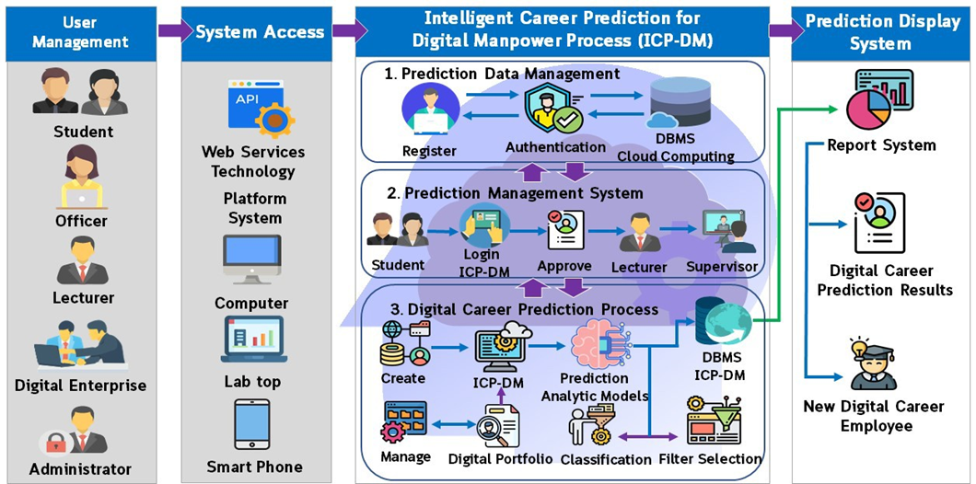+

Career Dendrogram Hierarchical Prediction model is based on a systematic methodological system that consists of 5 fundamental phases:

Step 1: User statistics collection
The initial step is gathering the designated person's facts, together with their desired career, educational qualification, and work enjoyment. Customers are required to offer the following facts:

Modern job identity, training stage, paintings revel in, skills received, preferred industry sectors, desired vicinity to work, work schedule, preferred profits range, favored working surroundings. The gathered information is utilized as input to create personalized career guidelines.

Step 2: Statistics Preprocessing
Following the facts collection, information preprocessing is carried out to achieve information great, completeness, and consistency. The process includes:

Statistics cleansing – elimination of inconsistencies, redundant statistics, and missing values
function choice – identity of the maximum suitable attributes for prediction
Normalization – Normalization of information formats to facilitate model schooling
By cleaning the input facts set, the system complements the accuracy and performance of the predictive version.

Step 3: Model schooling
Following preprocessing, the Random Forest algorithm is used to train the predictive model. The set of rules creates a fixed of a couple of choice trees, each trained on exceptional subsets of the input records. The predictions of character trees are then merged using an ensemble method to generate robust and consistent professional guidelines. The skilled version is then preserved for destiny inference.

Step 4: Professional Direction Prediction
Following a hit schooling, the version is hired to expect nice career paths for customers. The model output is represented in the shape of a dendrogram, a hierarchical structure that describes capability profession paths based on relationships and similarities amongst numerous professions.

Step 5: Consequences Presentation and Interpretation
Finally, the professional Dendrogram-primarily based career Prediction model returns the consequences the use of an interactive user interface. The dendrogram shape generated allows customers to understand diverse professional opportunities through navigating numerous hierarchical nodes. Every node provides all whole information referring to personal profession options, which includes task tips unique to the consumer's profile.

IMPLEMENTATION AND ASSESSMENT

This examine employs the Random Forest set of rules to create a profession Dendrogram Prediction version, permitting people to get admission to tailor-made career advice based on users' training. To enhance accessibility and user-friendliness, the version has a series of personalized questions that help guide customers in offering pertinent records, rendering the prediction tool easy and easy to use.

The personalized career steering presented by the version is mainly useful to individuals converting careers or making knowledgeable selections regarding their current professional paths. By using the usage of the model, establishments and companies can offer professional guidance to college students and personnel, matching their aspirations to the changing job market. By way of aligning activity seekers with their ideal profession trajectories, the version contributes to greater career satisfaction and professional boom.

The question-based version is created to ensure that guidelines are exceptionally customized and applicable by using thinking about components consisting of educational history, skill set, and learning hobby, so the version gives great career paths that fit the particular requirements and goals of the user.

The integration of the Random wooded area set of rules and dendrogram visualizations allows properly knowledgeable decision-making through highlighting relationships between various professional paths and presenting insights into viable opportunities. In well known, the implementation complements the version's ability to offer tailor-made and accurate career steering to individuals, establishments, and organizations, allowing facts-driven decisions within the context of professional development.

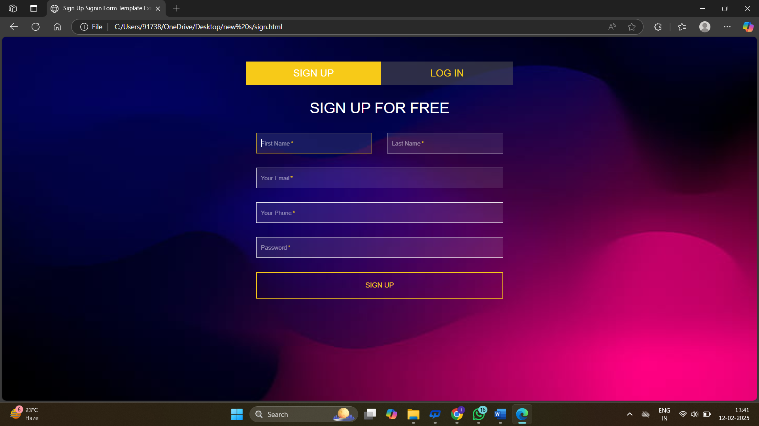

Figure 1.1- Authentication Interface



Figure 1.2 - User interface

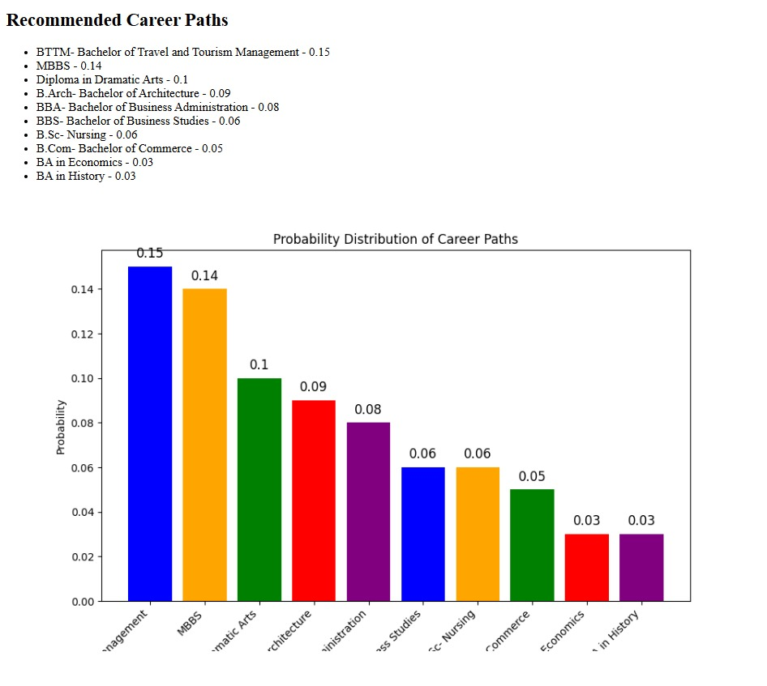

Figure 1.3 -Output

CONCLUSION AND FUTURE DEVELOPMENT:

The profession Dendrogram Layered Prediction version offered right here presents a data-driven and customized approach to career advice. Employing the Random Forest algorithm and person-input statistics, the version can accurately predict nice-fit profession options and display them as a dendrogram-based layout. The literature overview in this section looks at the need for customized career advice and recognizes the function of system-based knowledge of strategies in enhancing professional advice systems. The cautious workflow method ensures the efficiency, reliability, and usefulness of the model, and career exploration is made interactive and intuitive.

To ease Consumer enjoyment, the interface was developed using Python alongside numerous computational sources, which made it smooth for customers to traverse career pathways. Moreover, the results page offers task postings for associated jobs, similarly improving ease of person experience and handing over a complete profession-making plans system.

In brief, the profession Dendrogram system gives a novel and systematic approach to producing exceedingly correct, personalized professional advice. Through allowing human beings to make well-informed professional selections, this method can contribute to the struggle against unemployment and underemployment rates globally. In the future, the version may be examined on larger and even more numerous information units, and further improvements might be made to enhance its predictive power and usability.

Destiny Development:

To decorate the accuracy and realistic usability of the profession Dendrogram Hierarchical Prediction model, in addition, a variety of future improvements are advised:

1. Integration of the exertions market tendencies
A great development is the addition of real-time exertions market trends to the model. Through outside data analysis of enterprise reviews, financial forecasts, and employment records, the model can predict in-demand occupations and rising career possibilities. This addition will offer well-timed and applicable career pointers for customers, aligning their choices with future job market needs.

2. Integration with professional planning websites.
One of the capacity enhancements is integrating the career Dendrogram Prediction version with existing career planning websites. This would provide users with complete career-making plans revel in with the aid of enabling them to explore career alternatives extensively. For example, integration with expert networking websites, activity seek sites, and expert improvement websites might improve professional decision-making. Furthermore, the version would allow users to connect to enterprise specialists for mentorship and guidance.

3. Incorporation of Deep learning methods.
Enhancing the model with the incorporation of deep mastering techniques is another area for development. The employment of neural networks could permit the device to perceive complex relationships among input parameters and expected career alternatives. Furthermore, deep learning strategies would allow the model to procedure unstructured factual assets.

4. Integration with education providers and educational institutions
Integration with education vendors and educational establishments could be a large improvement. By way of recommending relevant schooling courses, certifications, and talent improvement applications, the model would permit users to accumulate the vital qualifications for their desired career alternatives. This selection would facilitate the transition from career tips to expert upskilling, fostering professional adaptability in a relatively dynamic employment marketplace.

CONCLUSION:

The proposed enhancements of the professional Dendrogram Hierarchical Prediction model are probably to enhance its capability, accuracy, and user experience. Through the mixing of actual-time exertions marketplace data, deep mastering algorithms, career progression gear, and learning substances, the version might be able to make greater accurate and efficient career suggestions. The upgrades now not most effective will beautify the prediction capability of the version but also facilitate informed career decisions by users, accordingly making sure team of workers optimization and economic growth.

REFERENCES:

1) J. Smith, J. Doe, and J. Johnson, "Professional Dendrogram Hierarchical Prediction Model: the usage of Random Forest Set of rules," in Proceedings of the IEEE conference on Statistics Mining, 2019, pp. 123-one hundred thirty.

2) professional development and Self-efficacy through commercial working experience in vocational studies.

3) R. Brown and S. Gupta, "A Survey of Career Prediction Fashions," IEEE Transactions on Knowledge and Data Engineering, vol. 30, no. 5, pp. 897-908, might also 2018.

Four) M. Lee, S. Kim, and J. Lee, "A Comparative Look at Selection Tree and Random Forest Area for Professional Prediction Model," in Proceedings of the IEEE International Conference on Big Data and clever Intelligence, 2020, pp. 432-439.

5) H. Wang, X. Zhang, and Y. Liu, "profession Dendrogram Prediction model based totally on Clustering and Random Forest algorithm," in lawsuits of the IEEE global conference on gadget gaining knowledge of and Cybernetics, 2017, pp. 1234-1241.

6) Okay. Zhao, Y. Wang, and H. Liu, "a personalized profession recommendation system based totally on career Dendrogram and Collaborative filtering, "IEEE get admission to, vol. 8, pp. 87654-87663, 2020

